Weekend Assignment

1. Smart Home Temperature Control

Pseudocode

Start

Initialize the sensor, LCD;

Set T=0, setPoint=0;

While True (do),

T=Read temperature from sensor()

If T==Error Then

Print “Sensor failed”

Else

Print “Current temperature:” ,T

Print “setPoint temperature:”,T

If(T>setPoint) then

Print “Activate cooling system”

Else if (T<setpoint) then

Print “Activate heating system”

Else

Print”Temperature is at SetPoint”

End if

End if

End While

End

Flowchart

Temperature at setpoint

Activate heating system

If T<SetPoint

If T>setPoint

Activate Cooling System

Print “Temperature,SetPoint

Sensor failed

If T==Error

Read temperature

While True

Set T=0,setpoint=0

Initialize Sensor,Lcd

No

Yes

No

Yes

NO

Yes

2.Automated Plant Watering System

Pseudocode

Start

Set moistureLevel=0;

Set threshold=200, pump=4000;

Initialize the sensor, waterpump, Led, SD card;

While True (do),

moisture=Read moistureLevel from sensor

Print “Moisture level”, moistureLevel

If moisture level<Threshold then

Print “Activate the water pump for a specified duration”

Turn Led and Water pump on

Wait

Turn water pump and led off

currentTime= Get currentTime

Print “Watering event at current time:”,currentTime

End if

End while

End

Flowchart

Set moistureLevel=0,Threshold=200,waterPump=4000

Initialize moisture sensor,water pump,Led, SD card

While True

Get current time and Print “Watering at current time”

Turn off LED, waterPump

Wait

Turn on LED,waterPump

Print “Activate the water pump”

If moistureLevel < threshold

Read moistureLevel,Print MoistureLevel

Yes

No

3. Motion Detection Alarm System

Start

Set motionDetected=false;

Set alarmActive=false;

Set motionDuration=0;

Set threshold=5;

Initialize Pir Sensor, Buzzer, UART,Reset;

While True (do),

motionDetected=Read motion from pir sensor

If motionDetected then

motionDuration=motionDuration+1;

If motionDuration >=threshold then

Print “Activate Alarm”

Turn on Buzzer

Send notification on UART as “Motion Detected”

Set alarmActive = true;

End if

Else

Print “No motion detected”

motionDuration=0;

If alarmActive then

Print “Deactivate alarm”

Turn off Buzzer

Set alarmActive = false;

End if

End if

If isReset then

If alarmActive then

Turn off Buzzer

Send notification on UART “Alarm Resetted”

Set alarmActive = false;

End if

End if

End While

End

Flowchart

Set motionDetected=false,alarmActive=false,motionDuration=0,threshold=5

While True

motionDetected=Read from pir

If motionDetected

Yes

motionDuration = motionDuration + 1

No

If motionDuration>=threshold

No motion detected

Activate alarm,turn on buzzer,send “motion detected” on UART

Yes

Reset motion duration=0

Set alarmActive =”true”

No

If alarmActive

Yes

Deactivate alarm

No

4.Heart rate monitor

Start

Set heartRateData=[]

Set heartRate=0, sampleCount=0;

Initialize heartRateSensor, Buzzer, LCD, SDCard;

While True (do),

CurrentHeartRate=read heartRateSensor

If currentHeartRate<0 then

Print“sensor failed”

Else

Write currentHeartRate to SDCard

heartRate+=current heartRate

sampleCount+=1

average heartRate=heartRate/sampleCount

Print “Current heart rate”,currentHeartRate

Print “Average heart rate”, averageHeartRate

If currentHeartRate >100 then

Alert()

End if

logRate(current heartRate)

end if

end while

end

Flowchart

Set heartRateData=[],heartRate=0,sampleCount=0

Initialize Sensor,Buzzer,LCD,Sdcard

While True

CurrentHeartRate = read heartRateSensor

If currentHeartRate<0

No

heartRate += currentHeartRate; sampleCount += 1

Write currentHeartRate to SDCard

Print 'Current heart rate, Average heart rate', currentHeartRate, averageHeartRate

averageHeartRate = heartRate / sampleCount

Yes

Sensor failed

If currentHeartRate > 100

No

logRate(currentHeartRate)

Yes

Alert()

5.LED Control Based on Light Sensor

Start

Set threshold=100;

Initialize lightSensor, LED, manualSwitch, feedbackLED ;

While True (do),

If manualSwitch is pressed

Set LED=Toggle

Set feedbackLED=blinking

else

Set feedbackLED=off

lightIntensity= Read lightSensor

if lightIntensity <=threshold then

Set LED=ON;

Else

Set LED=off;

End if

End if

End while

End

Flowchart

Set threshold=100

Initialize lightSensor, LED, manualSwitch, feedbackLED

While

If manualSwitch pressed

No

lightIntensity = Read lightSensor

Yes

IsflightIntensity <= threshold

No

Set LED = OFF

Set LED=Toggle

Set feedbackLED = off

Set feedbackLED = blinking

Yes

Set LED = ON

7. Temperature Logging System

Start

Set readArray=[]

Set readInterval=10 minutes

While True (do),

Temp=readTemperatureSensor

If temp<0 then

Print “Sensor failed”

Else

timestamp=currentTimeStamp

readArray.append((timestamp,temp))

logTempData(timestamp,temp)

end if

end while

end

function retrieveHistoricalData()

Print readArray

End function

Flowchart

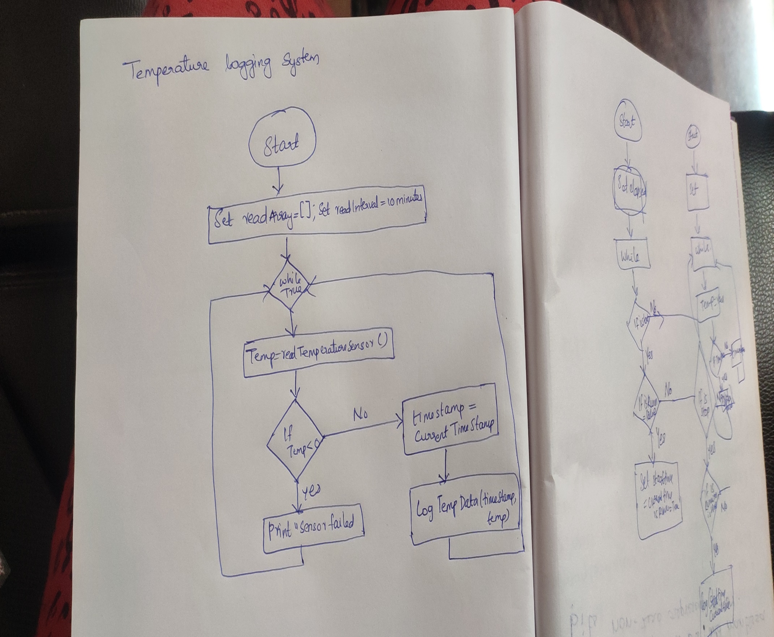

9.Battery monitoring System

Start

Set thresholdVoltage=11

Set sampleInterval=60 adcResolution=1024, Vref=5;

Initialize ADC,LCD,Buzzer,Memory;

While True (do),

adc=Read ADC value

batteryVoltage=Convert adc value to voltage(adc)

print batteryVoltage

if batteryVoltage<thresholdVoltage then

Alert()

Log event(record the low voltage in memory)

LowPowerMode()

End if

End while

End

Function convert adc value to voltage(adc)

Return(adc/maxAdc)\*Vref\*(R1+R2)/R2

End function

Function Alert()

Turn on buzzer

Turn off buzzer

End function

Function log Event(message)

Saving message to sd card

End function

Function LowPowerMode()

End function

Flowchart

